CYBERSECURITY TOOLS · WEEKLY LEARNING TRACK
Nmap Reference Documentation
Day 4 — Port Scanning Techniques

Prepared by Emmanuel Aidoo
Kali Linux · Nmap 7.98
September 18, 2026

Contents
1 TCP Connect Scan (-sT) 3
2 TCP SYN / Stealth Scan (-sS) 4
3 UDP Scan (-sU) 4
4 Key Takeaways 5

In this module, I compared three core port-scanning techniques Nmap offers against the same target(8.8.8.8). The techniques were: a full TCP connect scan, a SYN (“stealth”) scan, and a UDP scan performed to see exactly how they differ in mechanism and speed.

1 TCP Connect Scan (-sT)
-sT asks the operating system to complete a full TCP three-way handshake (SYN → SYN-ACK → ACK) with every target port, using the same connect() system call any normal application would use. It doesn't need raw-socket access, so it works without root privileges but every connection it opens is a real, fully-established one that the target can log.
● ● ●
$ nmap -sT 8.8.8.8
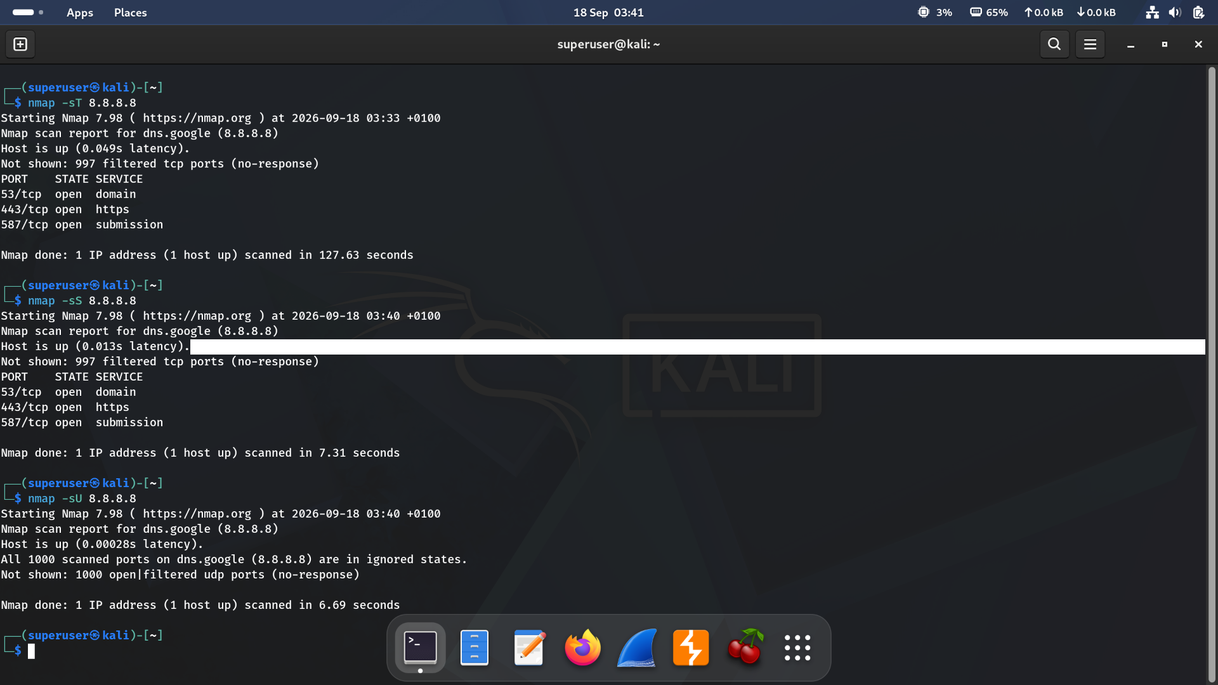
Figure 1 · TCP connect scan, SYN scan, and UDP scan run back-to-back against 8.8.8.8
Result summary
Port | State | Service
53/tcp | open | domain
443/tcp | open | https
587/tcp | open | submission

What I observed!
997 of the 1000 scanned ports came back filtered (no response) at 0.049s latency. The full scan took 127.63 seconds by far the slowest of the three techniques in this module, which is the direct cost of completing a real handshake on every one of those 1000 ports.

2 TCP SYN / Stealth Scan (-sS)
-sS sends only the initial SYN packet and waits for a SYN-ACK, then immediately sends a RST instead of completing the handshake. This is a “half-open” connection that's never fully established. Crafting raw SYN packets this way requires root privileges, but because no connection is ever completed, it's both faster and quieter than -sT. This is Nmap's default scan type when run as root.
● ● ●
$ nmap -sS 8.8.8.8
Result summary
Port | State | Service
53/tcp | open | domain
443/tcp | open | https
587/tcp | open | submission

Key difference from -sT
Identical result the same 3 ports open, 997 filtered but the scan finished in 7.31 seconds instead of 127.63. That's roughly 17x faster for the exact same information, because -sS never pays the cost of completing a handshake on each port. This is the core trade-off between the two: -sT needs no special privileges but is slow and logged; -sS needs root but is fast and far less visible to the target.

3 UDP Scan (-sU)
UDP has no handshake to exploit, so -sU works completely differently: Nmap sends an empty (or protocol-specific) UDP packet to each port and waits. An ICMP “port unreachable” reply means closed; an actual application response means open; and the tricky part is no response at all is reported as open|filtered, because there's no reliable way to tell whether the port is open and silently ignoring the probe, or filtered by a firewall.
● ● ●
$ nmap -sU 8.8.8.8
Result summary
Aspect | Observation
Ports scanned | 1000, all reported as open|filtered (no-response)
Confirmed open ports | None — 8.8.8.8 didn't respond distinctly to any unsolicited UDP probe outside of DNS on 53
Scan time | 6.69 seconds

Why UDP results are ambiguous
Every one of the 1000 ports landed in the same open|filtered bucket — that's not a failed scan, it's the expected outcome against a host like Google's public DNS resolver that won't send ICMP unreachable messages for closed UDP ports and won't respond to probes on ports where nothing is listening. This ambiguity is inherent to the UDP protocol, not a limitation of Nmap. Note also that 6.69 seconds is unusually fast for a UDP scan real-world targets often rate-limit ICMP responses, which can stretch a full UDP scan to several minutes or more.

4 Key Takeaways
- -sT completes a full TCP handshake on every port requiring no special privileges, but slow (127.63s here) and fully logged by the target.
- -sS (SYN scan) never completes the handshake, so it needs root but ran roughly 17x faster (7.31s) for identical results this is why it's Nmap's default scan when available.
- -sU scans UDP ports using a fundamentally different model: no handshake, so “no response” is reported as open|filtered rather than a definite state.
- Choosing a scan type is a trade-off between speed, stealth, privilege requirements, and the protocol being tested and not just a matter of picking whichever flag is fastest.

